*Arman Zoeb Kanorwalla - 20899832*

*EARTH 440 | University of Waterloo*

*field Trip Guidebook*

The Quaternary Glacial Geology of the Waterloo and Cambridge region.

**Field Trip 1: Introduction to the last glaciation, Waterloo Region, Ontario**

**Introduction**

Welcome to the guidebook for the field trip focusing on the Quaternary geology of the Waterloo region, Ontario. This trip provides an insightful exploration into the region's geological past, particularly emphasizing the Quaternary stratigraphy shaped largely by glacial processes during the Last Glacial Maximum. The Waterloo region, once entirely under the Laurentide Ice Sheet (Figure 1), presents a fascinating case study for understanding glacial dynamics, erosion, transport, and deposition processes. The ice sheet, approximately 1.5 kilometres thick, played a pivotal role in the region's topography through glacial dynamics involving erosion, transport, and deposition processes (Clark et al., 2009). This guidebook aims to dissect these intricate geological phenomena, offering students a comprehensive understanding of the field through scientific and academic lenses.

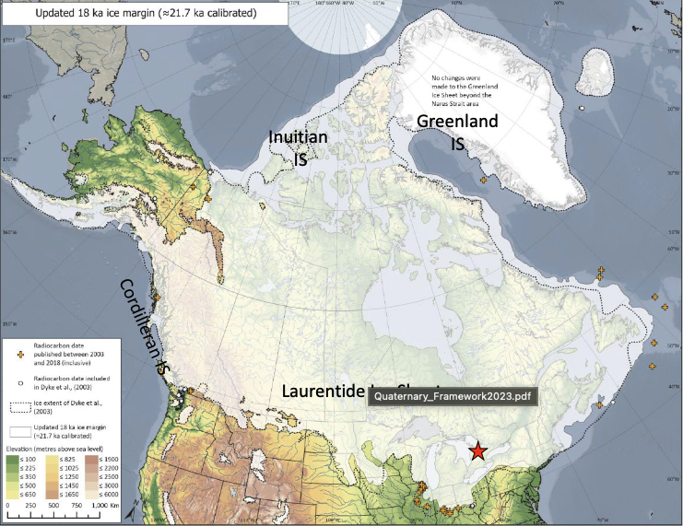

Figure 1. The Red star indicates the Waterloo region that was under the massive Laurentide Ice Sheet (Dalton, et al., 2020)

In Waterloo Region, Quaternary sediments are prevalent and exhibit a diverse range of characteristics. These sediments are primarily the result of glacial activity and can be categorized into several distinct types. One common sediment type is poorly-sorted sediments known as diamicton, which are created by glacial processes. Additionally, till, stratified, and sorted sediments generated by glacial meltwater processes are abundant in the region. Glaciofluvial sediments, fine-grained sediments deposited in glacial lakes, and glacial lake sediments also contribute to the geological composition of the Waterloo Region.

**Itinerary**

* Date & Duration: September 12th, 2023. 2:30 p.m. - 5:20 p.m.
* Location: Erosional bank of the Grand River
* Maps:

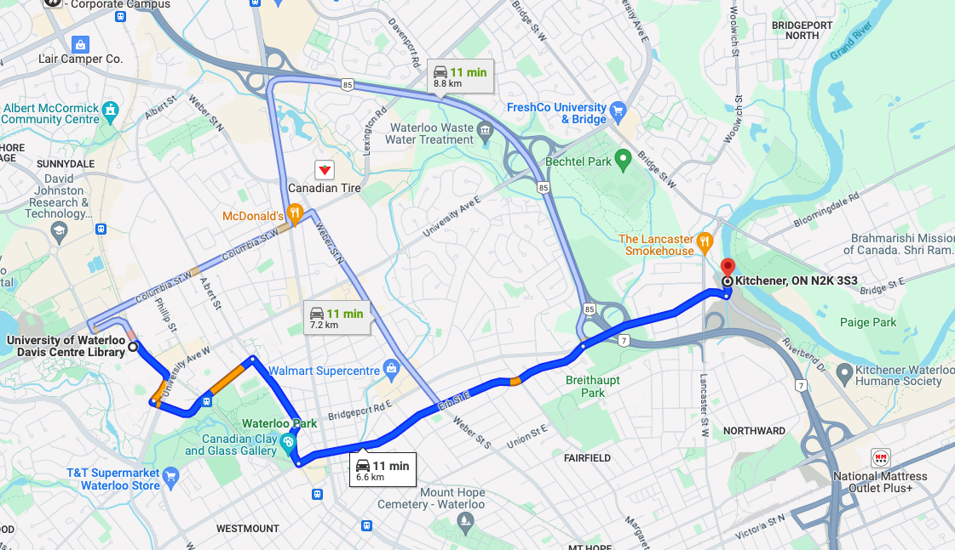

Figure 2. We see the directions and estimated time to this field trip’s location.

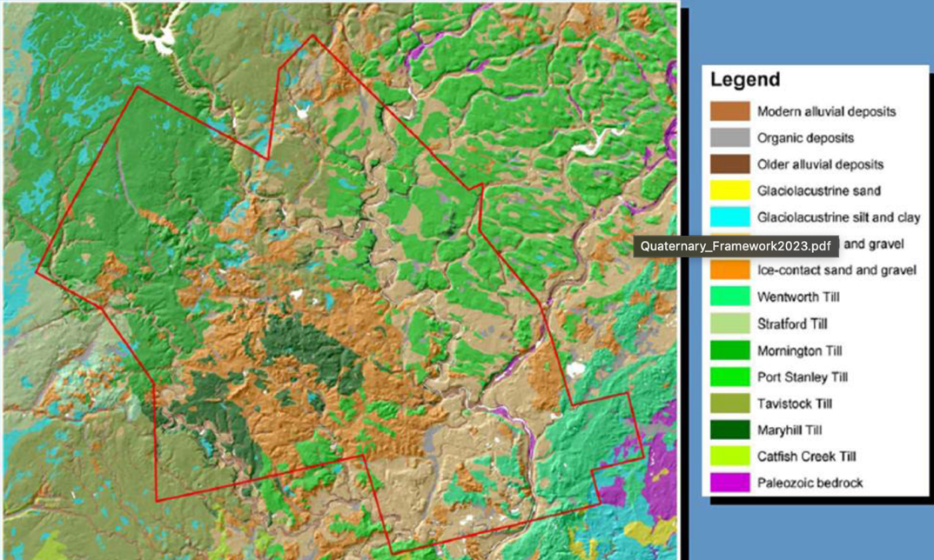

Figure 3. The Detailed Quaternary geology of the Waterloo region can be seen here.

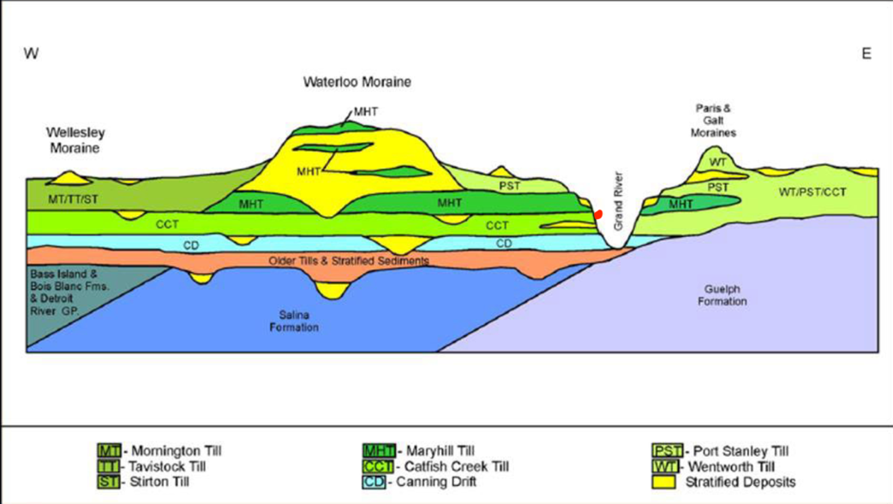

Figure 4. The red dot shows the stratigraphic location of our field trip area (Adapted from Bajc et al., 2014).

To better understand our field trip area we will use a shovel to dig into the banks of the Grand River to analyse the sediment.

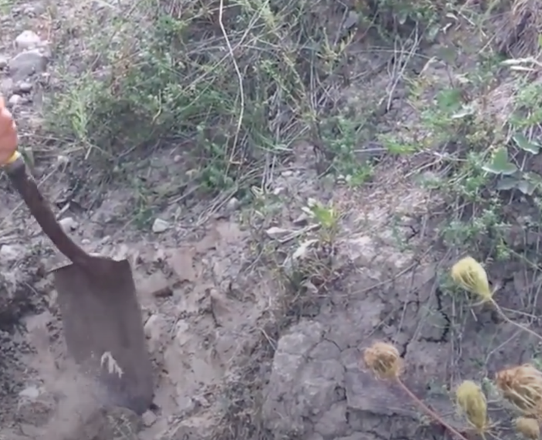

Figure 5. Shows how we dig into the river bank to reveal till fabrics.

**Detailed Descriptions of the areas key feature:**

**Grand River's Erosional Bank (Coordinates: [43.481833338572706N, 80.48223942503641W])**

*Catfish Creek Till:*

The Catfish Creek Till in Waterloo region, a Last Glacial Maximum deposit, is a poorly sorted subglacial diamicton known for its over-consolidation due to thick glacial ice pressure. This has made the till dense and easily identifiable in subsurface work (Martin Ross, 2020).

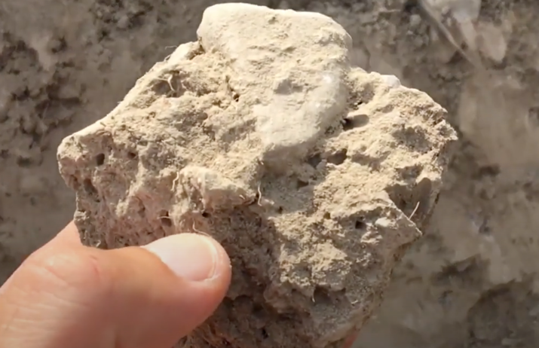

Figure 6. here we see the over consolidated fabric of the catfish creek till.

Despite its discontinuity, it's one of the most extensive Quaternary units in the area, averaging 15 meters in thickness but reaching up to 60 meters in some areas. It's primarily exposed along erosional river banks.

A detailed analysis in Bradtville, Ontario, reveals it comprises four massive diamicts, interspersed with sand and gravel, formed under active ice and influenced by melt-water, related to the late Wisconsinan Erie Lobe's dynamics (Huntley, 1991).

A notable characteristic is its high Canadian Shield material content, unusual for its location but attributed to southward transport by thick glacial ice (Martin Ross, 2020). These aspects make the Catfish Creek Till a key marker bed in regional geological studies.

*Glacial Clasts:*

Glacial clasts, as observed in formations like the Catfish Creek Till, offer a unique window into past glacial processes. These clasts often display a combination of sub-rounded and sub-angular edges, indicating a history of physical weathering and transport (Martin Ross, 2020). Faceting and polishing of these clasts further signify their glacial origin. A key feature to note on these clasts is the presence of fine striations, which can vary in direction. This variance is due to the clasts' rotation and interaction with other particles during transport within the glacial till or at the base of the ice (Martin Ross, 2020).

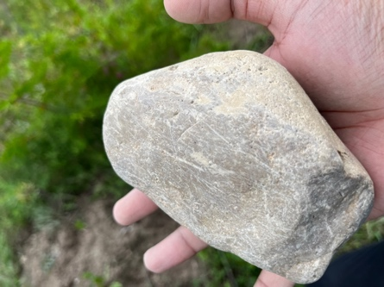

Figure 7. Shows a Glacial clast full of striations.

The composition of the clasts, or their lithology, significantly influences their ability to acquire such striations. Softer rocks, particularly carbonates like limestone, are adept at developing these delicate striations. In contrast, coarser-grained rocks, such as metamorphic or igneous types, may not exhibit striations as prominently (Martin Ross, 2020). The presence of striations, especially on faceted clasts within a deposit, is a definitive indicator of a glacial environment, as no other natural Earth processes can replicate these specific features.

*Other Till Units:*

The Catfish Creek Till is found alongside the Grand River and is overlain by younger deglacial sediments. These overlying sediments vary in origin; they can be glaciolacustrine, indicating formation in glacial lakes, or fluvial, originating from river activity. Glaciolacustrine sediments typically have a higher clay content, evident in the darker, clay-rich layers observed in the area (Martin Ross, 2020).

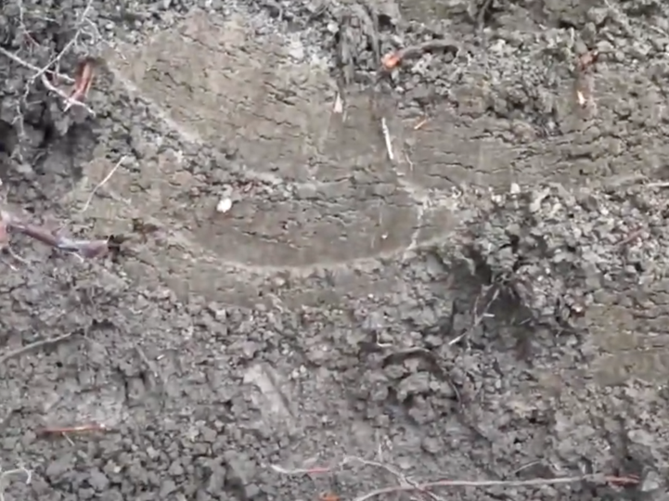

Figure 8. Shows the darker Maryhill Till.

During deglaciation, clay deposited by glacial lakes mixed with new till due to ice re-advances, forming a clay-rich diamicton. This material, unlike the typical laminated lacustrine deposits, is often interpreted as till despite its few clasts and differs from the Catfish Creek Till.

The reworked glaciolacustrine material is identified as the Maryhill Till. It is massive, stiff, with low clast content, and believed to have been overridden by ice, thus classified as till. Its composition, primarily from glacial lake sediments, reflects the environmental dynamics of the deglaciation period.

**Conclusion**

This field trip provides an in-depth perspective on the Quaternary geology of the Waterloo region, highlighting the transformative role of glacial dynamics during the Last Glacial Maximum. Examination of key geological units, particularly the Catfish Creek Till, reveals the intricate interplay between glaciation, erosion, sedimentation, and geological processes at play (Ehlers and Gibbard, 2004). These insights, while focused on a specific region, contribute significantly to the broader understanding of glacial geology and Quaternary studies, offering a window into past climatic and environmental conditions (Benn and Evans, 2010). The detailed exploration of the Waterloo region's glacial stratigraphy and dynamics provides valuable lessons in the Earth's geological history, enriching our understanding of global glacial processes.

**Field trip 2: Exploring the Waterloo Moraine and Conestogo Lake area**

**Introduction:**

The first field trip explored the Catfish Creek till, a geological unit in the Waterloo region linked to a period of significant ice coverage, including the last glacial maximum. In contrast, the second field trip, shifts focus to the deposits and features associated with the deglaciation period. This phase marks the retreat of ice, forming significant geological features in the area. We will closely examine the Waterloo Moraine, during this field trip. Our exploration is enriched by the insights provided by the regional surficial geology map of Southern Ontario, guiding us through a vivid tapestry of till sheets, glacial lake sediments, and fluvial deposits.

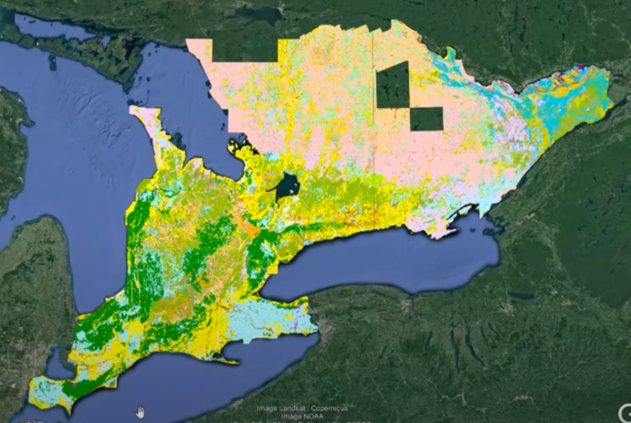

Figure 9. shows us the quaternary geology of southern Ontario

As we delve into the Waterloo Moraine, we explore a landform and sediment body that covers a large portion of the Waterloo and Kitchener cities and several townships (Martin & Frind, 1998). This moraine, the largest of fourteen in the region, spans approximately 400 square kilometres and is primarily composed of sand and gravel (GRCA & MPC, 2011). It was formed by the retreat of the Laurentide Ice Sheet's three ice lobes from Lake Huron in the west, Georgian Bay in the northeast, Lake Ontario in the east, and Lake Erie in the southeast (Blackport Hydrogeology Inc. et al., 2009). This retreat left behind a complex of glacial sediments, ranging from 30 to over 100 meters thick, consisting of boulders, sand, gravel, and bedrock deposits (Martin & Frind, 1998).

Through this field trip, we aim to provide a comprehensive understanding of the region's glacial and post-glacial landscapes, emphasizing the significant role of these geological features in shaping the current environment of Southern Ontario.

**Itinerary**

This field trip has been divided into Parts A & B as we will be visiting 2 different locations on 2 different days.

**Part A:**

* Date & Duration: September 19th, 2023. 2:30 p.m. - 5:20 p.m.
* Locations:
  + Conestogo Lake area; Wellington County, southern Ontario.
    - Near the river banks
    - Along the lake on the side of the road where the road cuts into the overlying sediments and creates a cross-section for us to observe.
* Maps:

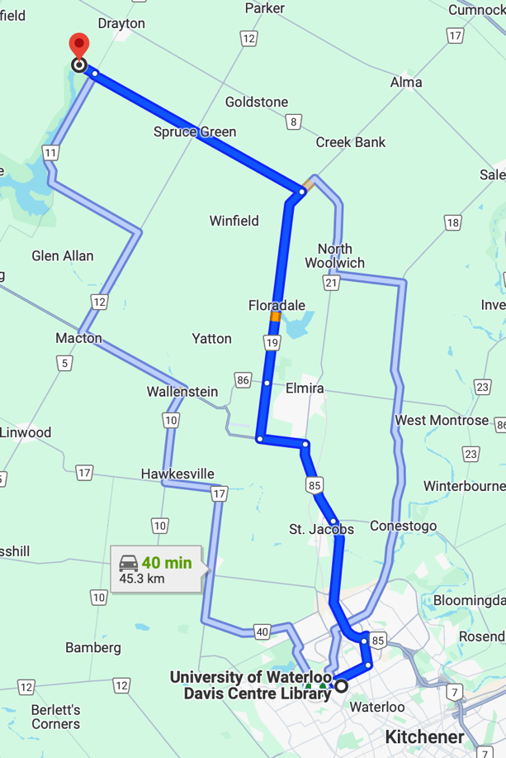 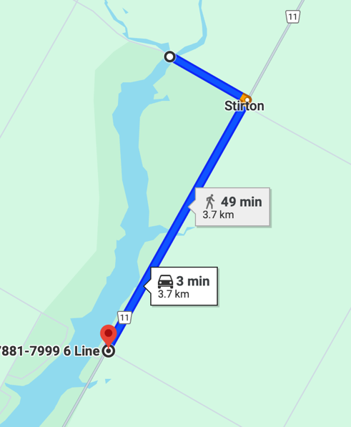

Figure 10 & 11. Show the directions and estimated time to reach our first and second stop (from the first stop) for this part of the field trip.

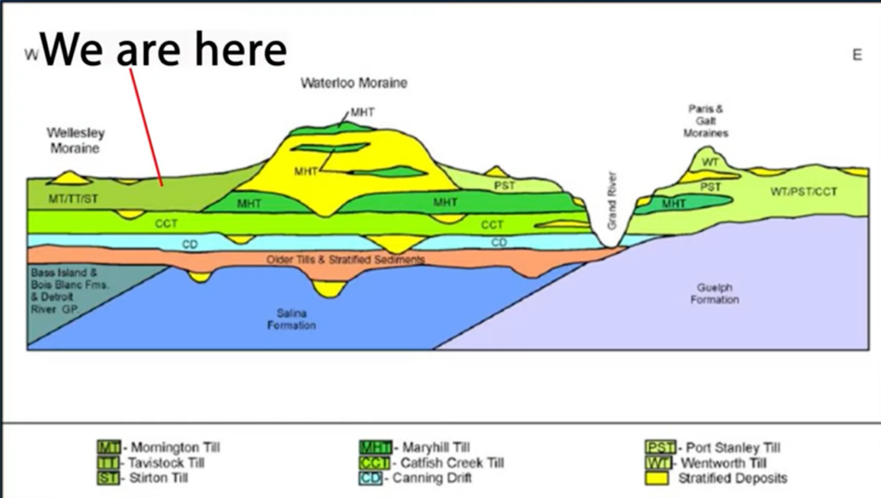

Figure 12. This stratigraphic cross-section marks our current location amidst the diverse glacial deposits of the field trip area (Adapted from Bajc et al., 2014).

**Detailed Descriptions of the area's key features**

**Conestogo Lake area; Wellington County, southern Ontario.**

The surficial geology of the Conestogo Lake area, located south of Drayton, is characterized by a series of quaternary deposits that provide insight into the region's last deglaciation. As depicted in figure 12., the area is notable for its deglacial till sheets, particularly the Mornington Till and the Tavistock Till. These tills were deposited by the Huron-Georgian Bay lobe, indicating that ice flowed from the Lake Huron basin towards the south-southeast into this region.

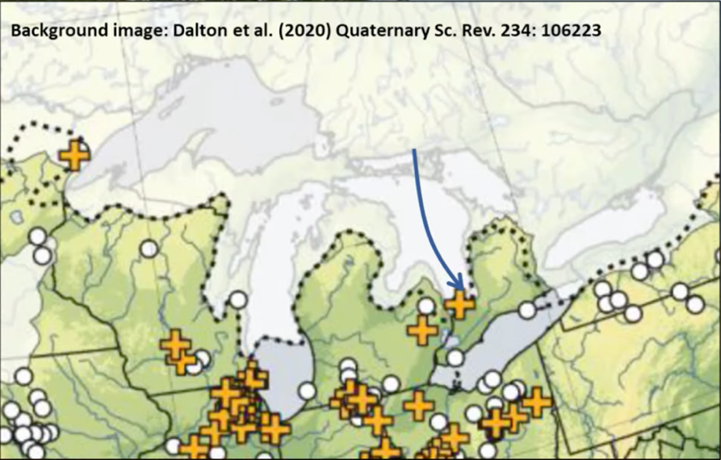

Figure 13 shows the glacial lobe that was present above our study area during the last glacial period (Adapted from Dalton et al., 2020).

*Near the Rivers and its erosional banks (43.73808329010425N, 80.69674291673114W):*

The riverbank near Conestogo Lake displays a vivid record of the area's glacial history, particularly showcased by the distinct layers exposed along its banks (figure 15.). As we look at the sediments that the river runs on we notice that it is a poorly sorted mixture, which includes an array of particle sizes from fine clay to larger, more angular clasts, which is characteristic of the Catfish Creek Till (figure 14.) (Martin Ross, 2020).

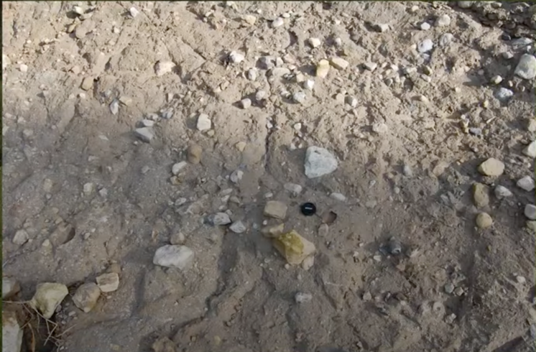

Figure 14. shows the till sheet located at the base of the river that the river runs on.

Another characteristic feature of the Catfish Creek till seen here is how over-consolidated its sediments (Martin Ross, 2020). The river banks as seen in figure 15., reveal a geological archive with layers of Catfish Creek Till and overlying Tavistock/Mornington tills, capped by Glaciolacustrine sediments.

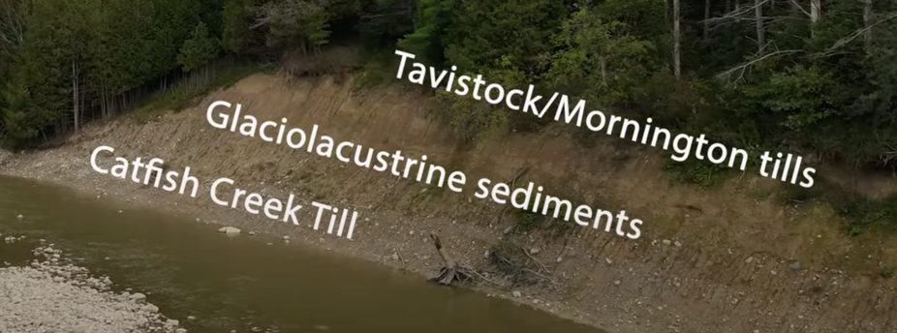

Figure 15. shows us the erosional banks of the river near conestogo lake displaying the till stratigraphy.

*Along the lake on the side of the road where the road cuts into the overlying sediments and creates a cross-section for us to observe (43.714308566487645N, 80.70391907061936W):*

Upon reaching our second destination, we will employ shovels to excavate a section (as seen in figure 16.) beside the road, uncovering the till sheet for our detailed examination. These tills, remnants of the most recent glacial deglaciation, are distinct features of the Conestogo Lake region. Notably, this area is defined by the presence of Mornington and Tavistock tills, intermingled with sediments from ancient glacial lakes. This combination vividly illustrates the landscape transformations during the late glacial period (Dyke et al., 2002).

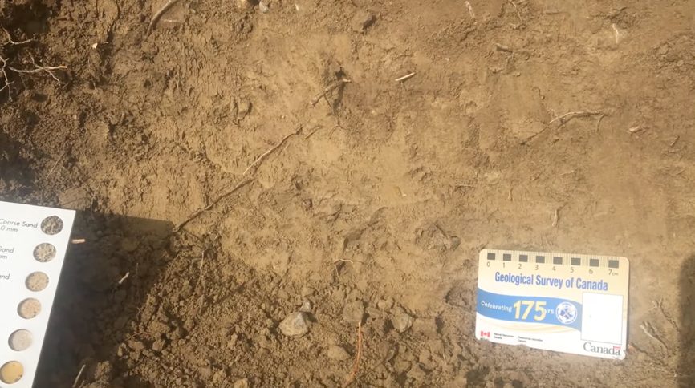

Figure 16. shows a field view of the Tavistock Till with a Geological Survey of Canada scale for reference.

*Glacial tills:*

These tills are typically fine-grained, consisting mainly of a silty matrix interspersed with very fine sand (Martin Ross, 2020). The composition reflects the varied sediment sizes that glaciers grind down and transport as they move.

Upon closer inspection of these tills, one would notice their brownish-buff colour, which becomes more apparent when digging below the oxidized surface (figure 16.). This colouration is indicative of the natural weathering processes that have occurred since their deposition. The texture of the tills is predominantly fine-grained, with a substantial amount of silt, which underscores their massive and dense nature (Martin Ross, 2020).

A characteristic feature of these tills is their clast content, which is typically less than 10% (Martin Ross, 2020). These clasts are faceted and often exhibit polished surfaces and striations, signalling their glacial origins. They are embedded within a matrix that is roughly 40% carbonate, suggesting a significant limestone component. Many of the limestone clasts (figure 17.) within the Tavistock Till, for instance, serve as useful provenance tracers, linking them to the rocks of the Huronian Group from the north shore of Lake Huron (Martin Ross, 2020).

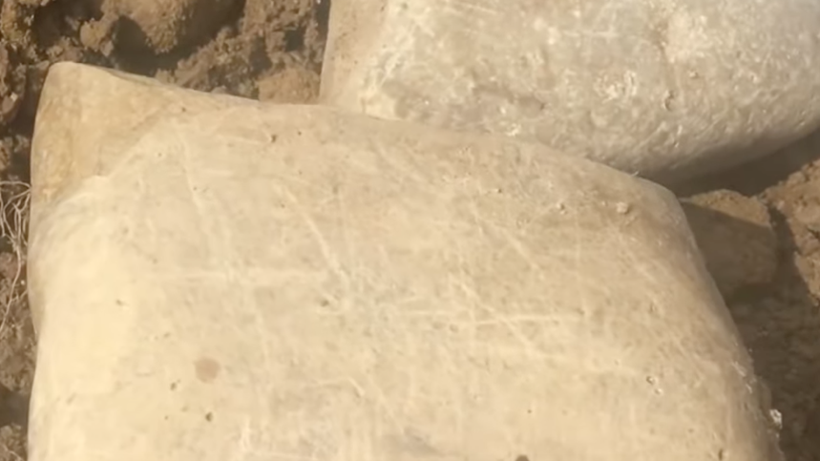

Figure 17. Shows polished limestone clasts with striations, showing the varied shapes from angular to sub-rounded.

The clasts within these tills vary from angular to sub-rounded shapes, which points to their transportation and abrasive history under the ice. Angular clasts have typically travelled a shorter distance from their source, while sub-rounded ones indicate more prolonged transport and weathering (Martin Ross, 2020).

*Laminated glacial lake sediment:*

The laminated glacial lake sediments in the Conestogo Lake area provide a delicate record of the climatic and environmental changes that have occurred since the last glaciation. These sediments, known as rhythmites, are characterized by their fine, layered structure, which reflects the cyclical nature of their deposition (Martin Ross, 2020).

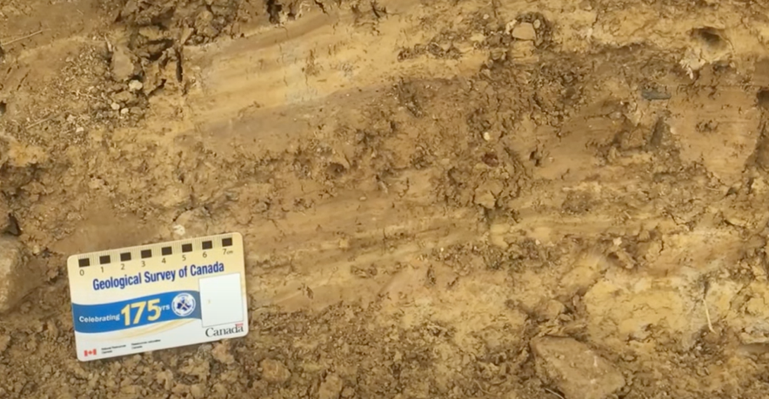

Figure 18. shows a cross-section of laminated glacial lake sediments.

Rhythmites are formed from alternating layers of sediment that differ in grain size and composition. In the context of the Conestogo Lake area, these sediments are typically fine-grained and mud-rich, indicative of a calm, lacustrine environment where fine particles could settle out of suspension (Martin Ross, 2020). Light-toned laminations within the rhythmites suggest layers of very fine sand to silt, which are slightly coarser and likely deposited during warmer seasons when meltwater inflow to the lake was at its peak. Conversely, the darker layers are clay-rich, indicating periods of less water flow, likely corresponding to colder, winter months when the lake surface was frozen over, reducing sediment inflow and allowing the finest particles to settle (Martin Ross, 2020).

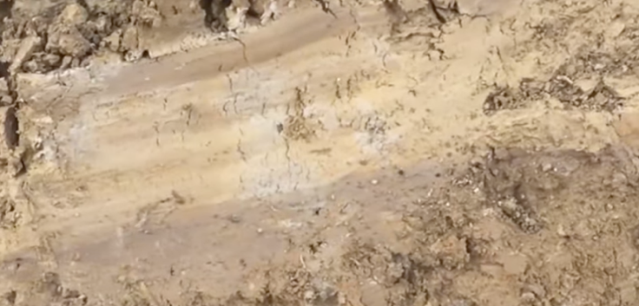

Figure 19. shows the rhythmites with their distinct light and dark banding.

The rhythmic nature of the sediments, with coarser layers indicating summers and finer, darker layers denoting winters, is evidence of seasonal variations (Martin Ross, 2020). These layers, known as varves, confirm annual cycles (Martin Ross, 2020). We interpret these as glacial lake deposits, distinct from typical lacustrine deposits, due to the presence of laminated silt and clay, and intercalated till sheets, which are indicative of calm glacial lake environments. These till layers act as chronological markers for the existence of a glacial lake (Martin Ross, 2020). The stratification, low organic carbon content, and lack of bioturbation suggest deposition in a cold, glacial setting (Martin Ross, 2020). Additionally, isolated dropstones and angular gravel, evidence of ice-contact processes, indicate the presence of icebergs in the glacial lake, depositing ice-rafted debris (IRD) into the sediments (Martin Ross, 2020).

**Part B:**

* Date & Duration: September 26th, 2023. 2:30 p.m. - 5:20 p.m.
* Locations:
  + The Waterloo Moraine near Baden Hill
  + The Waterloo Moraine near Hawkesville
* Maps:

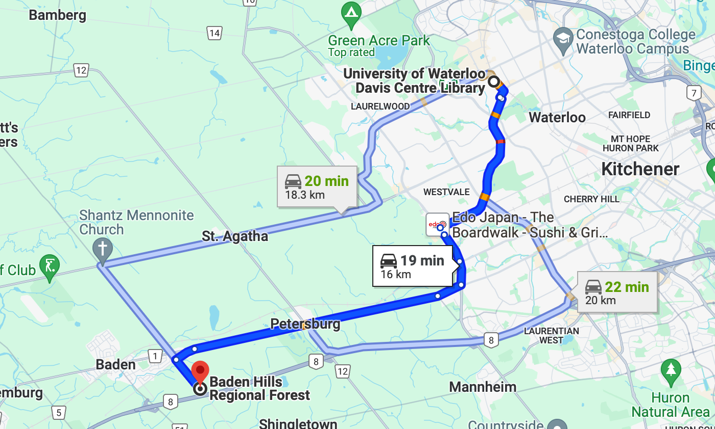

Figure 20. shows the directions to our main field trip stop for this part of the field trip.

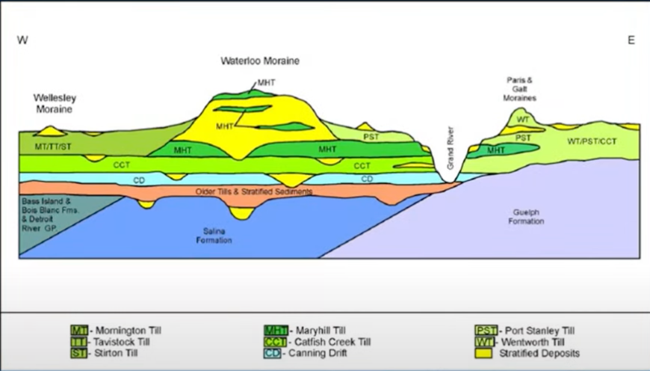

Figure 21. Shows the Stratigraphic cross-section of the Waterloo moraine (Adapted from Bajc et al., 2014).

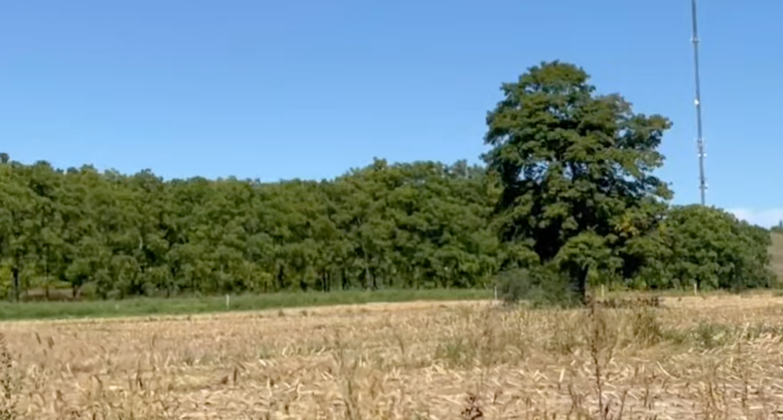

Figure 22. Baden Hill (a positive relief feature formed during the last deglaciation) can be seen here.

**Detailed Descriptions of the area's key features:**

*Waterloo Moraine near Baden Hill (43.39801172255434N, 80.64048442698689W):*

*Kame Deposit:*

Baden Hill (figure 22.) is a kame deposit that was formed during the last deglaciation. Kames are typically formed when sediments fill depressions on the surface of a glacier, in crevasses, or between ice masses. When the glacier melts, these sediments lose their icy support and are left behind, forming mounds or hills on the landscape.

In the analogy provided by Martin (2021), the sediments are compared to cereal filling a bowl; once the bowl (the ice) is removed, the cereal (sediments) is left in piles on the counter (the landscape). This process occurs at a much larger scale with kame deposits. They are highly heterogeneous, containing a mixture of silt, sand, gravel, and sometimes till lenses—sediments of various sizes and compositions that are dropped from the melting glacier (Martin, 2021).

Figure 23. illustrates two types of kame formations:

* Isolated Kame Hill (Baden Hill, figure 22.) (Diagram B in figure 23.): This shows a cross-section of a kame formed above a subglacial till, with flowed diamictons and stream deposits indicating water flow and sediment movement on top of the glacier. Below this, there is a local shallow basin filled with more flowed diamictons, indicating deposition in a depression on the glacier's surface (Benn and Evans, 2010).
* Kame Plateau (Diagram C in figure 23.): This represents a larger, plateau-like kame with deltaic facies and lacustrine facies on the top, indicating environments of sediment deposition by water flow and in glacial lakes, respectively. It also shows subglacial till and channel deposits beneath the kame, suggesting a complex depositional environment with both ice and water influences (Benn and Evans, 2010).

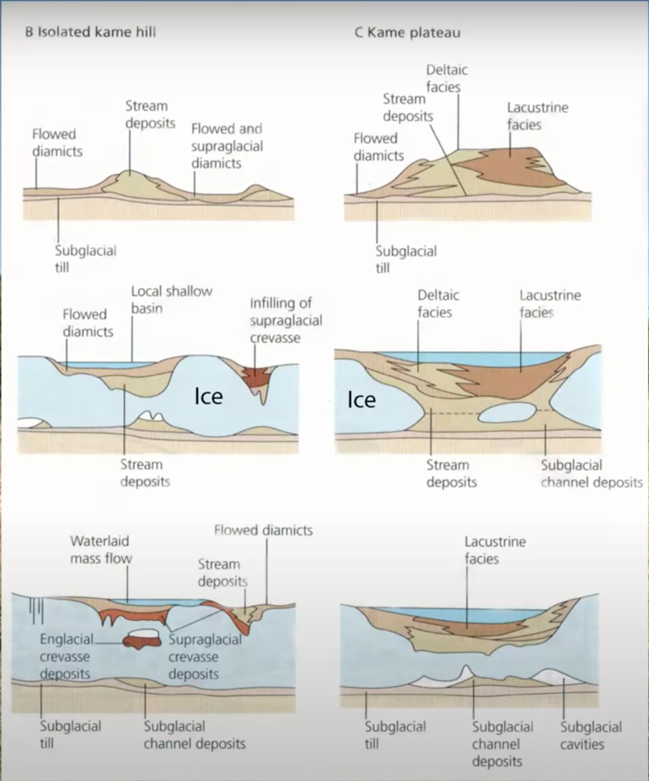

Figure 23. Cross-section diagrams of glacial sedimentary structures, including Isolated Kame Hill and Kame Plateau, modified from Benn and Evans (2010) 'Glaciers and Glaciation', p. 526

*Overview of regional deglaciation:*

During the deglaciation phase, ice became thinner and was strongly influenced by the topography. This resulted in the formation of large lobes of ice flowing along the Lake Ontario-Erie basin depressions, as well as Lake Huron and Georgian Bay, known as the Lake Huron-Georgian Bay lobes and Ontario-Erie lobes, respectively.

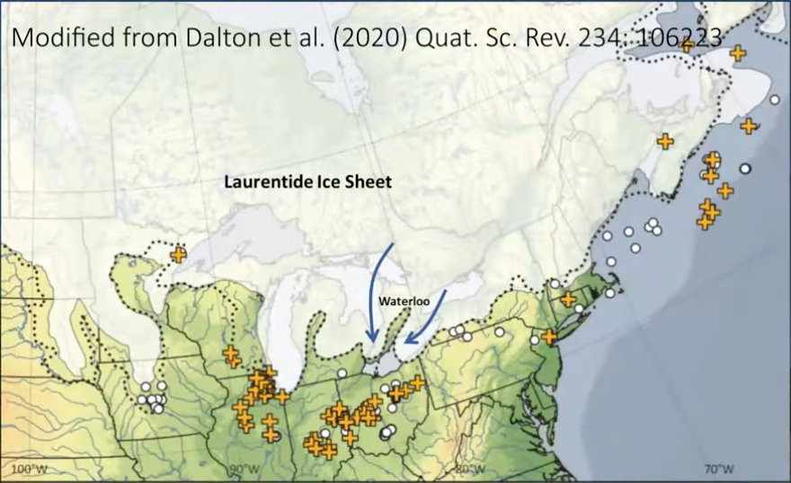

Figure 24. Map showing the regional deglaciation with the retreating Laurentide Ice Sheet and the formation of the Waterloo Moraine

As the ice sheet's margin began to recede, or "unzip," particularly in the Waterloo region (figure 24.), spaces were opened up for sediments to be deposited. However, ice persisted in the area for some time, behaving like a saddle over which materials were transported and deposited in depressions. When the ice support was removed, these accumulated sediments formed significant mounds on the landscape, creating features like the Waterloo Moraine.

*Waterloo Moraine near Hawkesville (unsure of coordinates as I did not record them during our fieldtrip stop):*

*Human activity on the waterloo moraine:*

The Waterloo Moraine is a key geological feature formed by the deposition of sediments during the last glacial period. The heat map-style image (figure 25.) shows the thickness of the main stratified sediment sequence in the Waterloo Moraine, with variations from 0 to 100 meters. The color gradient indicates the varying thicknesses, with red representing the thickest sediment accumulations. This variation in sediment thickness can influence the region's topography and hydrogeology.

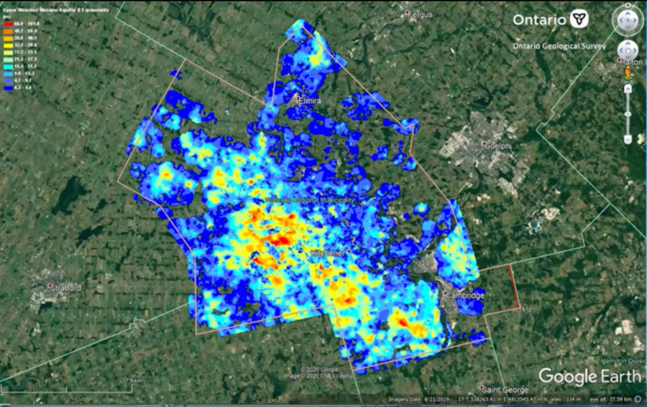

Figure 25. heat map showing the thickness of the main stratified sediment sequence in the Waterloo region.

Urban growth and development, such as in the Kitchener-South area along Huron Rd. and Fischer-Hallman Rd. (figure 26.) , are directly impacting the moraine. The construction and expansion of cities on the moraine necessitate careful management to preserve the integrity of this geological feature.

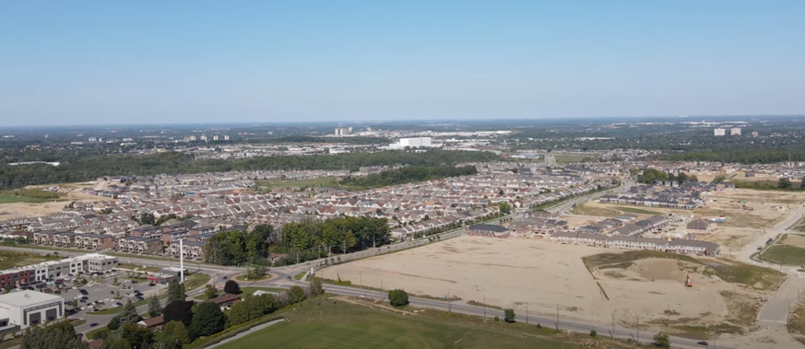

Figure 26. Urban development aerial shot of Huron Rd. and Fischer-Hallman Rd.

Moreover, the Waterloo Moraine serves as an important aquifer, providing water resources for the region. For instance, the Mannheim water treatment plant and aquifer water storage near Ottawa St. and Trussler Rd. are crucial for the local water supply. Human activities, including aggregate extraction and urban development, require sustainable practices to balance economic needs with environmental conservation.

**Conclusion:**

In the wake of our exploration of the Waterloo Moraine, it becomes clear that this geological feature is far more than an academic curiosity. Serving as a crucial water source for over a century, the moraine has been pivotal in supplying approximately 60% of the water to the Waterloo region, with its aquifers playing a vital role in the daily provision of fresh water to the community (Russell, Sharpe, & Bajc, 2005) (Stotler, Frape, & Labelle, 2014). This underscores the importance of a comprehensive understanding of the moraine's complex hydrogeology, which is marked by a multi-aquifer system and a history peppered with diverse ecological features (Blackport, Meyer, & Martin, 2014)

The effective management and sustainable utilization of the Waterloo Moraine's resources hinge on a nuanced grasp of its intricate stratigraphy, which includes multiple aquifers separated by regionally discontinuous aquitards. Such knowledge is critical for ensuring a reliable water supply amidst the challenges posed by urban expansion and environmental change (Bajc, Russell, & Sharpe, 2014). Thus, as we conclude our field study, we are not just leaving with a sense of the past glacial forces but also with an appreciation for the ongoing need to balance human activity with the preservation of this geological treasure. It's evident that the study and stewardship of the Waterloo Moraine are not only about preserving a legacy of the Earth's geological history but also about securing a sustainable future for the Waterloo region.

**Field Trip 3: East Cambridge (ON), Paris-Galt Moraine area**

**Introduction**

This field trip focuses on the Quaternary geology of an area east of Cambridge in Southern Ontario, exploring a region rich in glacial and post-glacial features. After examining the Waterloo Moraine, Conestogo Lake area, and Catfish creek till features in previous trips, this exploration shifts eastward to investigate the Paris-Galt Moraine and its associated landforms. This area offers a unique insight into the glacial dynamics of the Ontario Ice Lobe during deglaciation, providing a window into the past environmental changes and landscape evolution in this region (Ehlers and Gibbard, 2004).

Our exploration will take us to the Paris-Galt Moraine and its associated features, where the stratigraphy (figure 30.) tells a tale of ice advances over an outwash plain. We will examine the thick till sheets that form distinctive ridges with hummocky topography and the underlying extensive, laterally spread tabular sheets of gravel.

The tabular sheets of gravel extend laterally along the moraine ridges for several tens of kilometres. Interestingly, the outwash plain sediments are partially buried under till sheets of the moraine ridges (figure 27.). This suggests that the Ontario ice lobe advanced over its own outwash plain during the deglacial period.

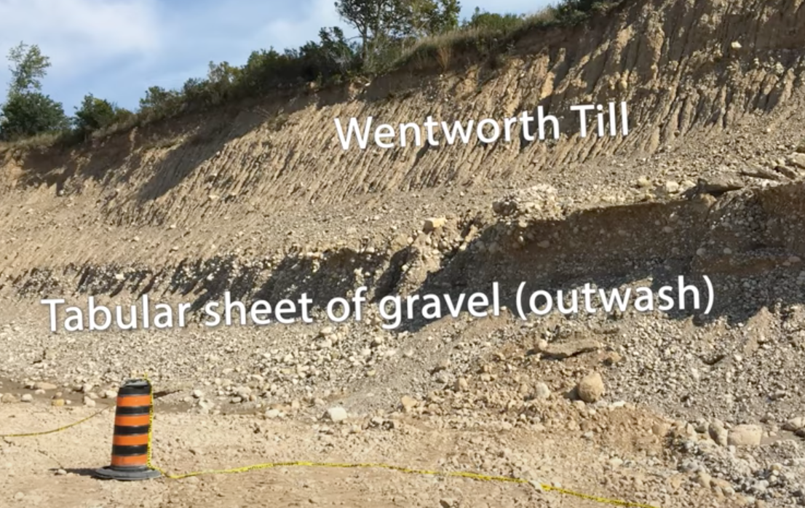

Figure 27. Shows the outwash plain buried under the Wentworth till sheet.

In this segment, we will interpret the past glacial and proglacial processes that shaped this landscape, revealing insights into the subglacial environment behind the moraines.

**Itinerary**

* Date & Duration: October 3rd, 2023. 2:30 p.m. - 5:20 p.m.
* Location:
  + Concession Rd 7, Puslinch, Ontario.
* Maps:

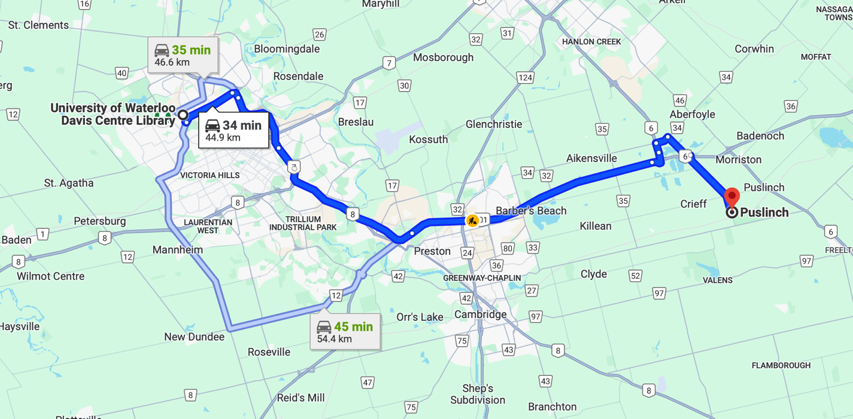

Figure 28. shows the directions to our main field trip stop

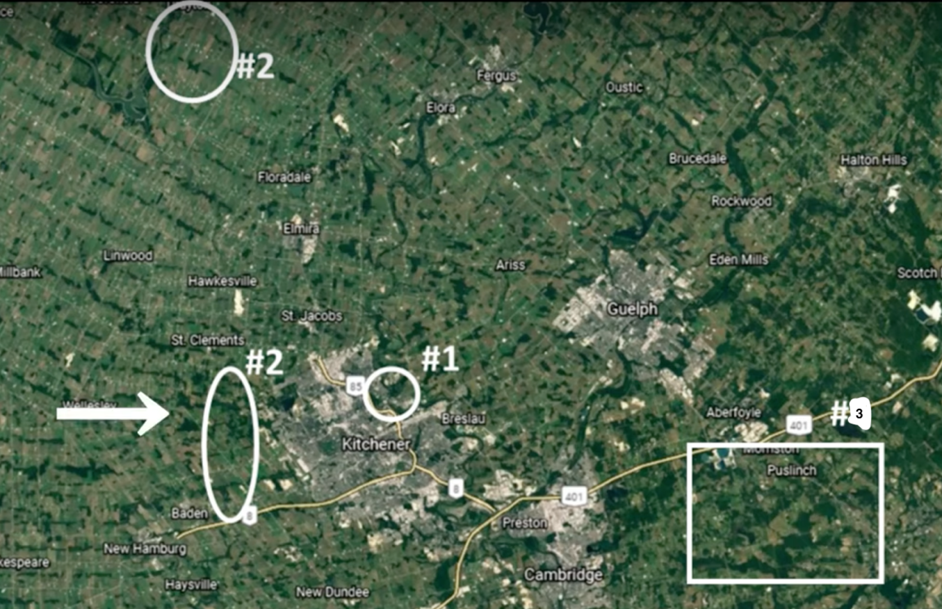

Figure 29. shows our different field trip study regions across the 3 field trips.

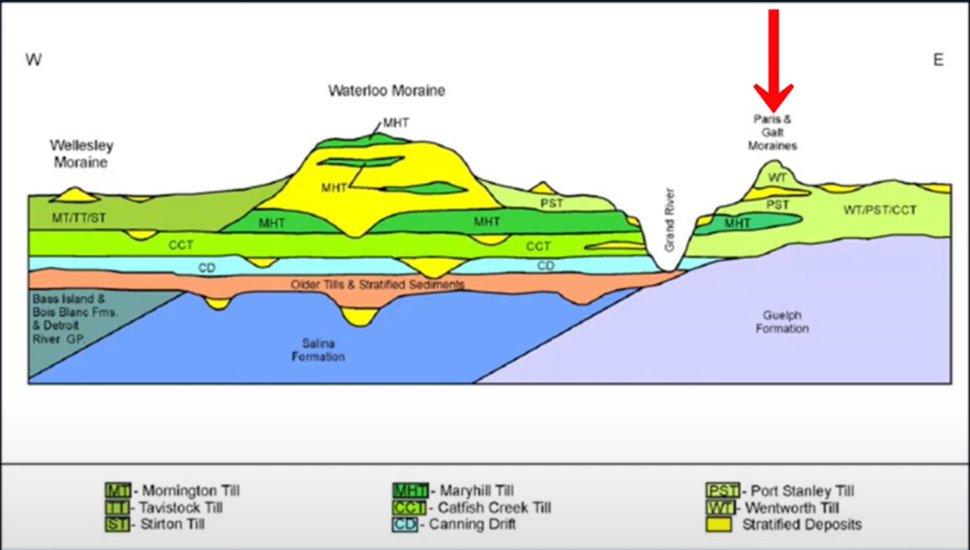

Figure 30. Shows the Stratigraphic cross-section of the Paris-Galt moraine (Adapted from Bajc et al., 2014).

**Detailed Descriptions of the area's key features(43.41895907126214N, 80.12225908646056W):**

*Wentworth Till:*

The Wentworth Till, as part of the Paris-Galt Moraine, exhibits a hummocky topography, indicative of its dynamic formative process (Martin, 2020). This till is characterised by a high clast content with substantial boulders, visible in the landscape. These boulders, often subangular, polished, and striated, offer tangible evidence of past glacial movement over the terrain (Martin, 2020). The images (figure 31.) show the gritty texture of the till, with boulders and a variety of smaller, subrounded stones embedded within a sandy matrix.

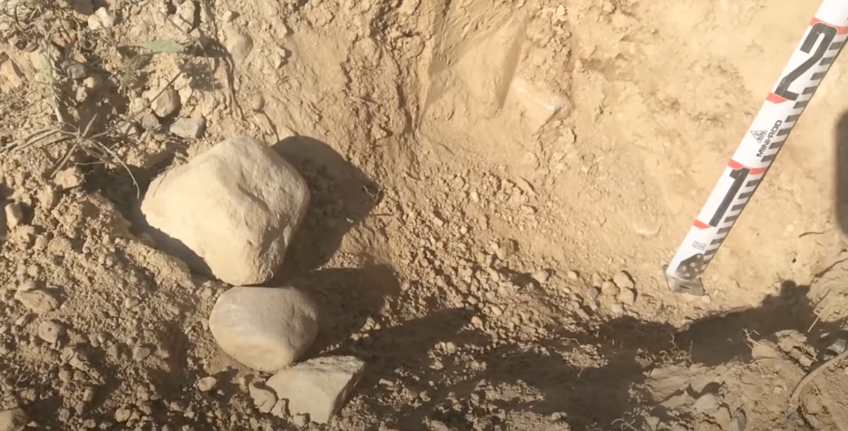

Figure 31. Reddish hue can be seen in the matrix of the till in the top right of the figure.

What is particularly notable about the Wentworth Till is the occasional reddish hue of its matrix, attributable to the presence of Queenston Shale from its source area near the Hamilton-Niagara Escarpment (Barnett & Karrow, 2018). The shale, not being resistant to glacial transport, is rarely found intact within the till; however, the red layers are ground down, imparting the distinctive colour to the matrix (Martin, 2020).

*Abraded and Quarried Bedrock:*

The bedrock near the Paris-Galt Moraine provides a rare and valuable look at the effects of basal ice sliding on bedrock. The images (figure 32.) captured show the smooth, polished surface of the carbonate rock, indicative of abrasion (Hindmarsh, 1985). This abrasion occurs when debris-rich ice, carrying particles as hard or harder than the bedrock itself, slides over and polishes the surface, leaving behind the striations seen in the images (Martin, 2020).

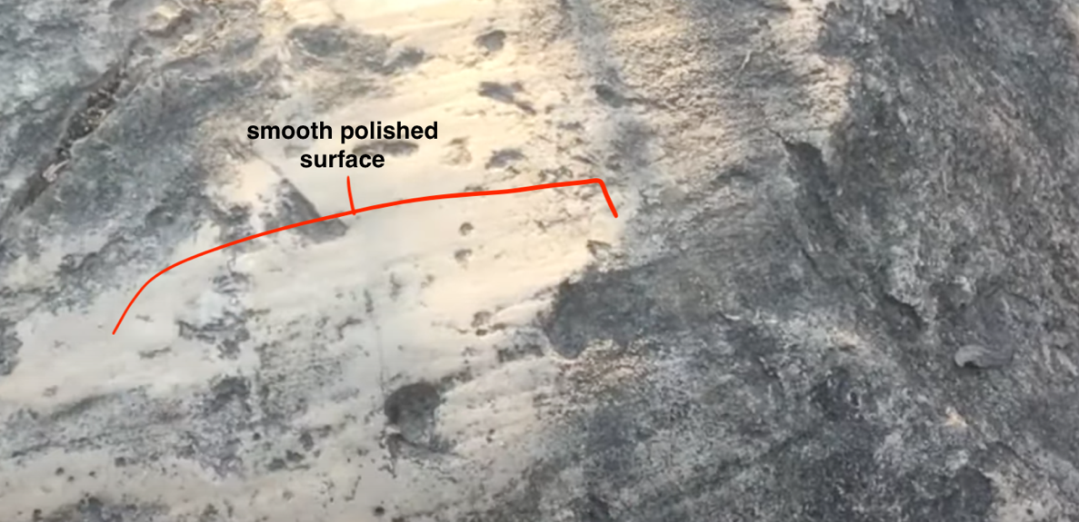

Figure 32. polished and striated carbonate rocks can be seen here.

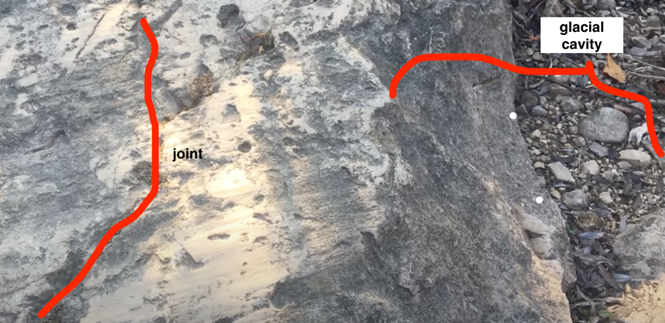

Figure 33. fissures in the outcropping bedrock

Additionally, the process of quarrying is visible where subglacial cavities form, leading to the plucking and entrainment of rock fragments. The photographs (figure 33.) display the joints and fissures within the bedrock, which contribute to its fragmentation under varying water pressures—a key factor in subglacial hydrology (Martin, 2020). Quarrying processes are evidenced by the presence of joints and fissures that facilitate rock fragmentation under variable water pressures, contributing to the creation of till by producing coarse particles that are transported and further broken down (Gjessing, 1965).

*Ice Flow Indicators and Direction:*

Determining the direction of ice flow is critical in understanding glacial movements and the resultant geological formations. One common method to ascertain this direction is by analyzing glacial striations on bedrock (Martin, 2020). The polished surface of carbonate rock (as seen in figure 32.) is a result of abrasion from debris-laden ice, with larger clasts creating scratches and finer particles polishing the bedrock surface (Hindmarsh, 1985). By measuring the azimuth of these striations, we can deduce the direction of past ice flows.

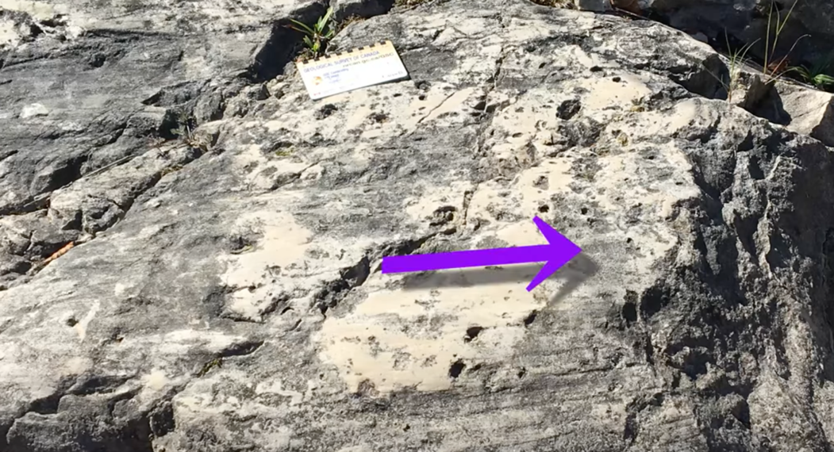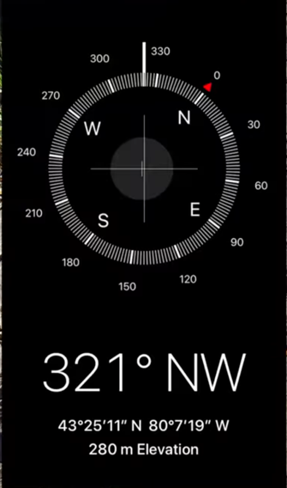

Figure 34. This image depicts striated bedrock with a purple arrow pointing along the direction of the striations. Using the compass app, the azimuth of these striations can be measured

In Figure 34., the striations indicate a northwest direction (321 degrees), which correlates with the flow direction of the Ontario ice lobe during the deposition of the Wentworth Till and the formation of the Paris-Galt Moraine (Martin, 2020).

*Sediment-Land System:*

The sediment-land system is a complex mosaic of geological materials and landforms, which are often contemporaneous and indicative of specific sedimentological environments (Martin, 2020). This system can be mapped (as seen in figure 35.) to illustrate the juxtaposition of various landforms and sediments, each representative of different glacial and proglacial environments.

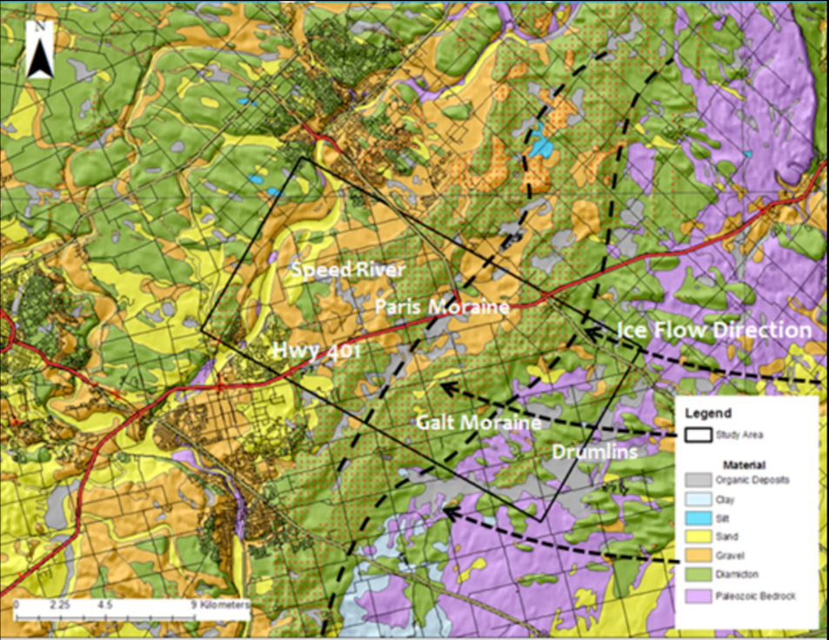

Figure 35. This geological map illustrates the distribution of different sediment types and landforms (adapted from Martin, 2020).

Figure 35. reveals the track of sediments and the orientation of drumlins, elongated ridges which are aligned parallel to the direction of ice flow, indicative of subglacial environments.

*Drumlins:*

The examination of a drumlin south of the Paris-Galt Moraine reveals its alignment and relationship with the direction of past glacial flow. Drumlins are streamlined forms shaped by glaciers, with their long axes typically aligning with the direction of glacial movement, indicative of the ice advance direction (Smalley & Unwin, 1968).

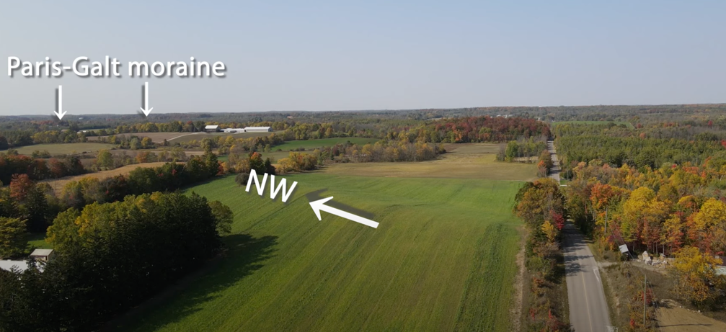

Figure 36. This photograph shows a drumlin in a field south of the Paris-Galt moraine.

The drumlin depicted in Figure 36, exhibiting a northwest orientation, corroborates with the striation directions previously observed, further confirming the northwest ward movement of the Ontario ice lobe during the period of Wentworth Till deposition and the construction of the Paris-Galt Moraine (Smalley & Unwin, 1968).

**Conclusion**

As we conclude our field trip exploring the Quaternary geology east of Cambridge, we have traversed through a landscape rich in glacial and post-glacial features. From the hummocky topography of the Paris-Galt Moraine to the polished and striated surfaces of abraded bedrock, we have uncovered the dynamic processes of the Ontario Ice Lobe (Martin, 2020). The orientation of drumlins and striations has provided us with clear indicators of ice flow direction, encapsulating a history of glacial movement and sedimentation (Martin, 2020). The intertwining of geological formations and the sediment-land system has painted a detailed picture of deglaciation, offering a comprehensive view of past environmental changes and landscape evolution in Southern Ontario. This journey through time has not only deepened our understanding of glacial dynamics but also highlighted the importance of geological features as storytellers of Earth's climatic past.

Reference:

Martin, P. J., & Frind, E. G. (1998). Modeling a complex multi‐aquifer system: The waterloo moraine. *Groundwater*, *36*(4), 679–690. https://doi.org/10.1111/j.1745-6584.1998.tb02843.x

Bajc, A.F., Russell, H.A.J., Sharpe, D.R. (2014) A three-dimensional hydrostratigraphic model of the Waterloo Moraine area, southern Ontario, Canada. Canadian Water Resources Journal, 39(2): 95-119

Ontario Geological Survey 2010. Surficial geology of Southern Ontario. Ontario Geological Survey, Miscellaneous Release-- Data 128-REV

Dalton et al. (2020) Quaternary Science Reviews 234: 106223

Clark, P. U., et al. (2009). The Last Glacial Maximum. Science, 325(5941), 710-714.

Martin Ross. (2020, September 2nd) Field Trip 1 - Introduction to the last glaciation, Waterloo Region, Ontario (Canada) [Video]. YouTube. <https://www.youtube.com/watch?v=M2aOkaJiDgY&list=PL9yX1LlwrJ6ZkDTOkk0KQYqjkAI_IHW0z&index=2>

Huntley, D. H. (1991). Lithofacies analysis of the Catfish Creek till: Bradtville, Ontario. Department of Geology, University of New Brunswick.

Ehlers, J., and Gibbard, P. L. (2004). Quaternary Glaciations - Extent and Chronology: Part II: North America. Elsevier.

Benn, D. I., and Evans, D. J. A. (2010). Glaciers and Glaciation, 2nd edition. Hodder Education.

Planning, Housing and Community Services, Grand River Conservation Authority (GRCA), and Meridian Planning Consultants Inc. (MPC) (2011). Protecting Significant moraines in Waterloo Region. Retrieved November 20th, 2023. URL: <https://web.archive.org/web/20110120034317/http://www.region.waterloo.on.ca/web/region.nsf/97dfc347666efede85256e590071a3d4/DF8D8858DE483EAF8525722D0059B543/$file/Phase%203%20report%202.pdf?openelement>

Blackport Hydrogeology Inc., Blackport and Associates Ltd., & AquaResource Inc. (2009). Review of the state of knowledge for the Waterloo and Paris/galt moraines. <https://guelph.ca/wp-content/uploads/Moraines_Report_May2009.pdf>

Martin Ross. (2020, September 15th) Field Trip 2C - Deglaciation (Conestogo Lake area) [Video]. YouTube. <https://www.youtube.com/watch?v=1AC8t0KlX4w&list=PL9yX1LlwrJ6ZkDTOkk0KQYqjkAI_IHW0z&index=6>

Martin Ross. (2021, September 20th) Field Trip 2B Last deglaciation (overview of Waterloo moraine) 2021v [Video]. YouTube. <https://www.youtube.com/watch?v=c3Sf0RkJ9jU&list=PL9yX1LlwrJ6ZkDTOkk0KQYqjkAI_IHW0z&index=4>

Dyke, A. S., et al. (2002). The Laurentide and Innuitian ice sheets during the Last Glacial Maximum. Quaternary Science Reviews, 21(1-3), 9-31.

Benn and Evans (2010) Glaciers & Glaciation. 2nd edition.

Russell, H. A. J., Sharpe, D. R., & Bajc, A. (2005). Sediment architecture and composition of the Waterloo Moraine, Southern Ontario: Emerging insights. <https://www.researchgate.net/publication/240230574_SEDIMENT_ARCHITECTURE_AND_COMPOSITION_OF_THE_WATERLOO_MORAINE_SOUTHERN_ONTARIO_EMERGING_INSIGHTS#:~:text=The%20Waterloo%20Moraine%20provi%20des,1997>

Blackport, R. J., Meyer, P., & Martin, P. (2014). Toward an understanding of the Waterloo Moraine hydrogeology. Canadian Water Resources Journal / Revue canadienne des ressources hydriques. <https://www.semanticscholar.org/paper/Toward-an-understanding-of-the-Waterloo-Moraine-Blackport-Meyer/134e97f7d6aac1308eb55826104d6574b8f46d7c>

Bajc, A., Russell, H., & Sharpe, D. (2014). A three-dimensional hydrostratigraphic model of the Waterloo Moraine area, southern Ontario, Canada. Canadian Water Resources Journal / Revue canadienne des ressources hydriques. <https://www.semanticscholar.org/paper/A-three-dimensional-hydrostratigraphic-model-of-the-Bajc-Russell/061c9990cc75031f2f2aec3c27d9e078da3ca6c9>

Stotler, R., Frape, S., & Labelle, L. (2014). Insights gained from geochemical studies in the Waterloo Moraine: Indications and implications for anthropogenic loading. Canadian Water Resources Journal / Revue canadienne des ressources hydriques. <https://www.semanticscholar.org/paper/Insights-gained-from-geochemical-studies-in-the-and-Stotler-Frape/d8be44989ee275ac16116d9be40a6ba2904c6170#:~:text=The%20Waterloo%20Moraine%20is%20a,discontinuous%20aquitards%2C%20complicating%20resource>

Martin Ross. (2020, September 28th) Field Trip 4 - East Cambridge (ON), Paris-Galt Moraine area [Video]. YouTube. <https://www.youtube.com/watch?v=nZOs9K7ocvE&list=PL9yX1LlwrJ6ZkDTOkk0KQYqjkAI_IHW0z&index=9>

Barnett, P. J., & Karrow, P. F. (2018). Onshore–offshore correlation of central Lake Erie glacial deposits. Canadian Journal of Earth Sciences, 55(11), 1250–1271.

Hindmarsh, R. C. A. (1985). Scratching of bedrock by glacial ice. Journal of Glacial Studies, 31(109), 438-446.

Gjessing, J. (1965). Till slurries as a scouring agent. Annals of Glaciology, 22, 41-47.

Smalley, I. J., & Unwin, D. J. (1968). The Formation and Shape of Drumlins and their Distribution and Orientation in Drumlin Fields. Journal of Glaciology, 7(51), 377-390.